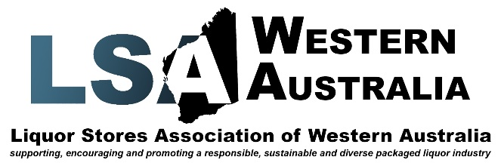

Chris Dawson
Western Australia Police Commissioner
2 Adelaide Terrace,
East Perth
WA, 6004

Dear Commissioner,
RE: Kimberley Alcohol Restrictions

I write to you in relation to the disturbing article published in “The West Australian” on Friday January 3, 2020, which stated alcohol related harm in the Kimberley was “13 times higher than the state average”.
As with most West Australians this level of harm is of great concern to our industry and our association (the LSAWA) and its members.
I’ve always believed when parties can “break bread” it helps pave a positive step towards reaching a common goal.
Therefore I am asking you to provide a time suitable to meet and discuss this issue further, so we can work with WA Police to try to come up with some workable and tangible solutions and contingencies.
I wish you a Happy New Year and I look forward to hearing from you soon,
Sincerely,
Peter Peck
CEO Liquor Stores Association of Western Australia

